|  |  |  |  |  |  |  |  |  |  |
| --- | --- | --- | --- | --- | --- | --- | --- | --- | --- |
| **Process Name** | | | Outpatient IV Iron | | **Location:** | WellSpan Health | | **Department:** | WFM / Specialty Practices |
| **Document Owner:** | | | Flack / Ebling | | **Date Created:** | 9/29/21 | | **Revision Date (s):** | 5/4/23 |
| **Trigger:** | | Iron Deficiency Anemia Requiring Parenteral Iron | | | | **Related Policies**: |  | | |
|  | | | |  | |  |  | | |
| **Process Steps** | | | | **Role Performing Task** | | **Key Point** | **Pictures, Diagrams, Workflows, etc.** | | |
|  | Place ambulatory order (not in a patient visit encounter) or Therapy Plans tab under Plan section (during a patient visit encounter). | | | Provider | | Diagnosis of iron deficiency not responsive to oral iron. | OR | | |
|  | Choose therapy plans. | | | Provider | |  |  | | |
|  | Choose “available”. Can also hit star to make it a “favorite”. | | | Provider | | Choosing product |  | | |
|  | **The preferred non-dextran IV product is specific per WellSpan region, pending insurance auth:**  East/Central/Gettysburg = ferumoxytol (feraheme)  Chambersburg/Waynesboro =  Iron sucrose (injectafer)  Pregnant patients =  Iron sucrose (venofer) | | |  | |  |  | | |
|  | Insurance plans and allergies may require you to choose alternative intravenous iron preparations. | | | Provider  May require Prior authorization from insurance (clinical staff). | | Choose IV iron product. |  | | |
|  | Check serum phosphorous before ordering **Injectafer** because hypophosphatemia is a potential complication. | | | Provider | |  |  | | |
|  | Order for infusion appointment is now embedded in Therapy Plan. Select local Infusion Room:  **Ephrata = ECH CANCER INF SVC**  **Lebanon = SEC CANC CTR INFU SVC**  **York = AHMC INFUS CTR**  **Adams = GH INFUS SVC**  **Hanover = HANOVER INFUS CTR**  **Chambersburg = CH INFUS SVC**  **Waynesboro = WAYH INFUS SVC** | | | Provider | | Need for infusion appointment | **Then:** | | |
|  | Repeat CBC in 6 weeks to assess response. | | | Provider | | Follow-up treatment response |  | | |
|  | If additional doses of IV Iron must be added to the plan after treatment has been completed, a new Appt Request order is necessary for the Infusion Room to schedule the patient. | | |  | |  |  | | |

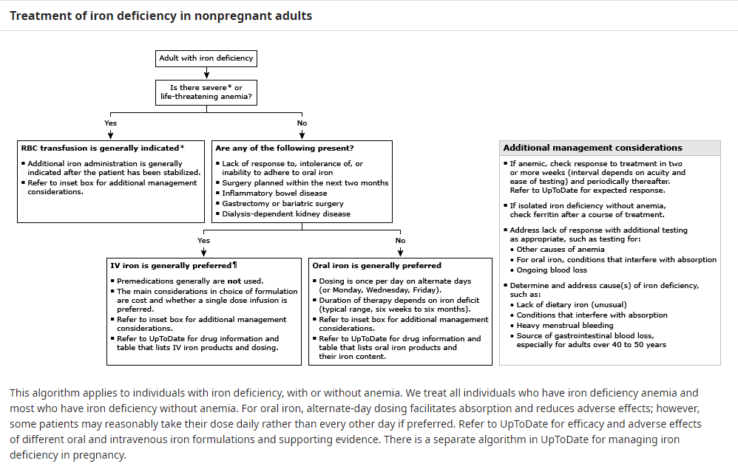

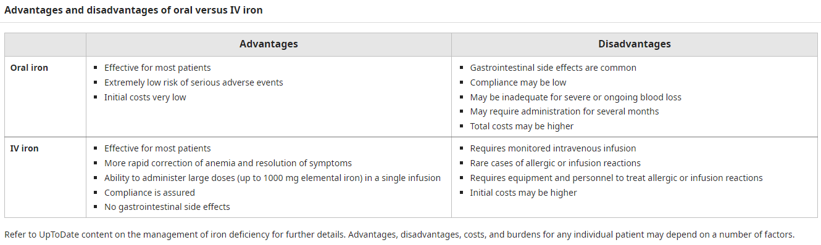

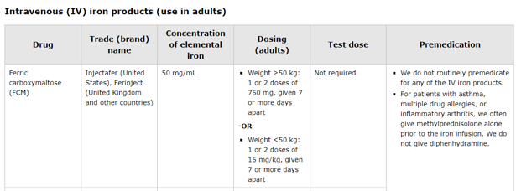

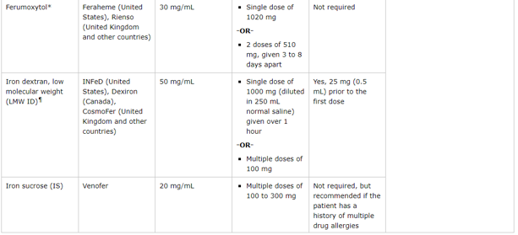

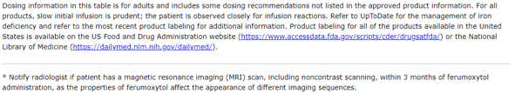

{Above graphic has been altered from UpToDate to account for WellSpan formulary}